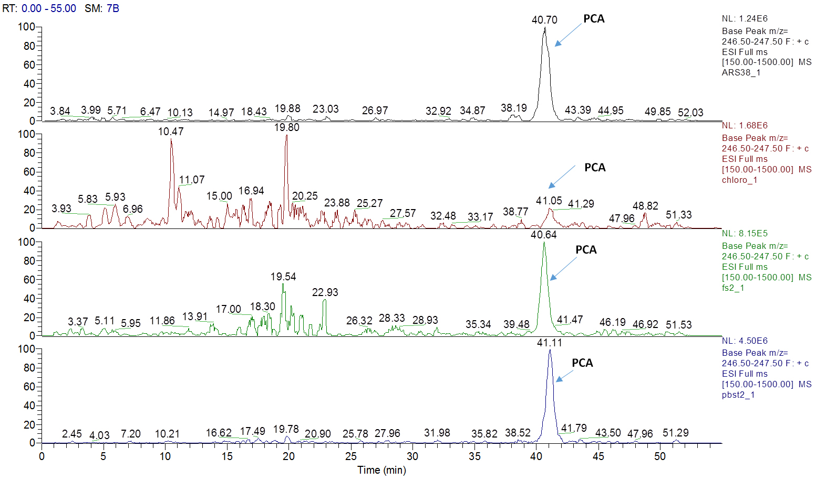
Figure S1. Extracted ion current (XIC) chromatograms for phenazine-1-carboxylic acid (PCA), m/z 225, [M + H]⁺ and m/z 247, [M + Na]⁺ of four strains; ARS-38, RP-4, FS-2 and PB-St2

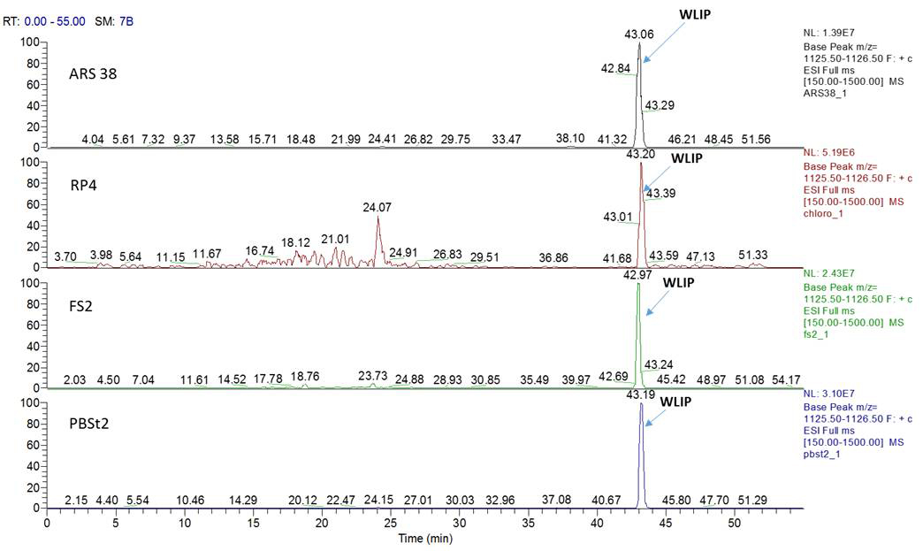
Figure S2. Extracted ion current (XIC) chromatograms for white-line-inducing principle (WLIP), m/z 1126, [M + H]⁺ of four strains; ARS-38, RP-4, FS-2 and PB-St2

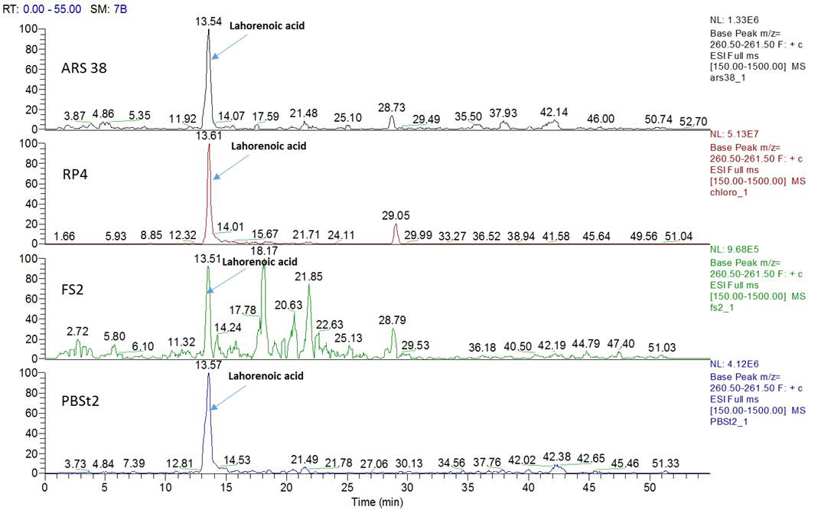
Figure S3. Extracted ion current (XIC) chromatograms for Lahorenoic acid A, m/z 261, [M + H]⁺ of four strains; ARS-38, RP-4, FS-2 and PB-St2

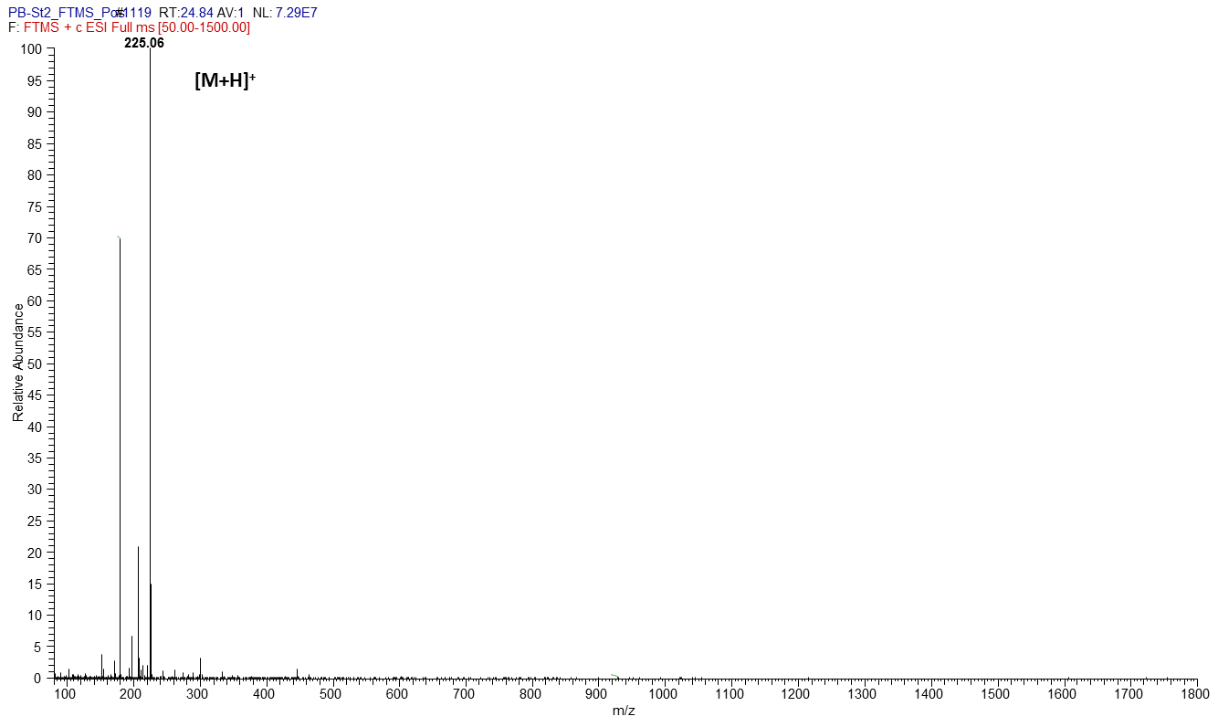
Figure S4. Mass spectrum of Phenazine-1-carboxylic acid (PCA), m/z [M + H]⁺ 225

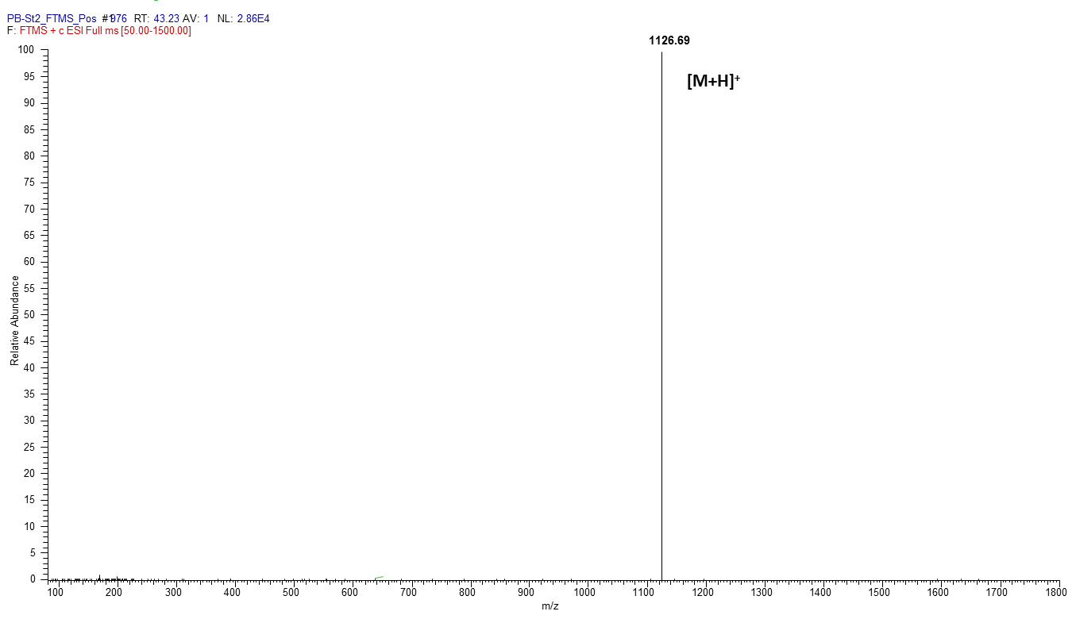
Figure S5. Mass spectrum of White line inducing principle (WLIP), m/z [M + H]⁺ 1,126

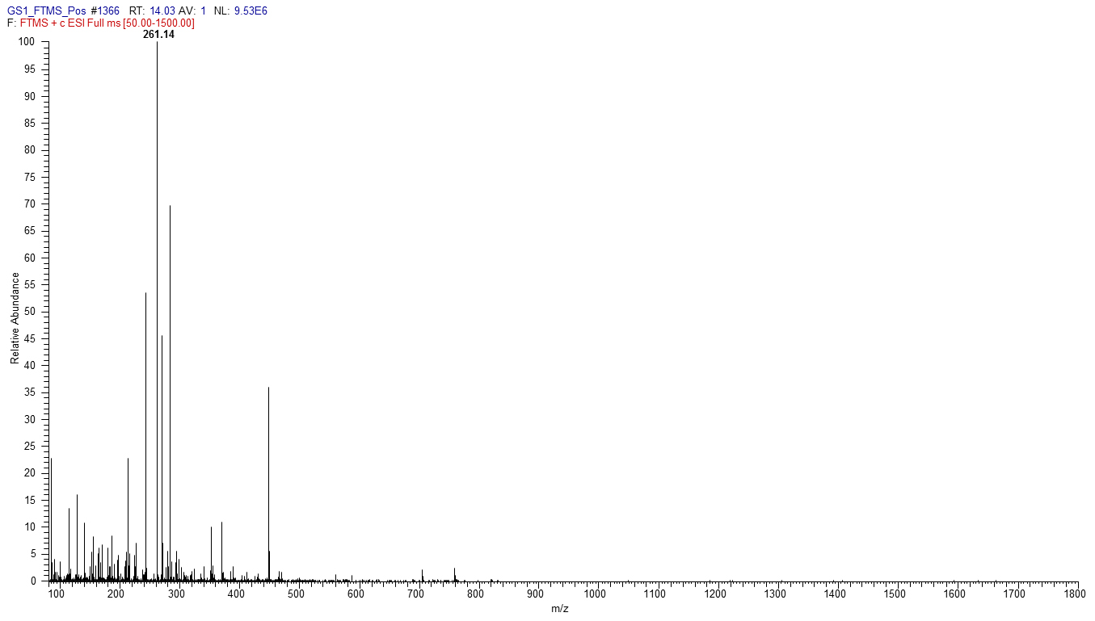
Figure S6. Mass spectrum of Lahorenoic acid A, m/z [M + H]⁺ 261

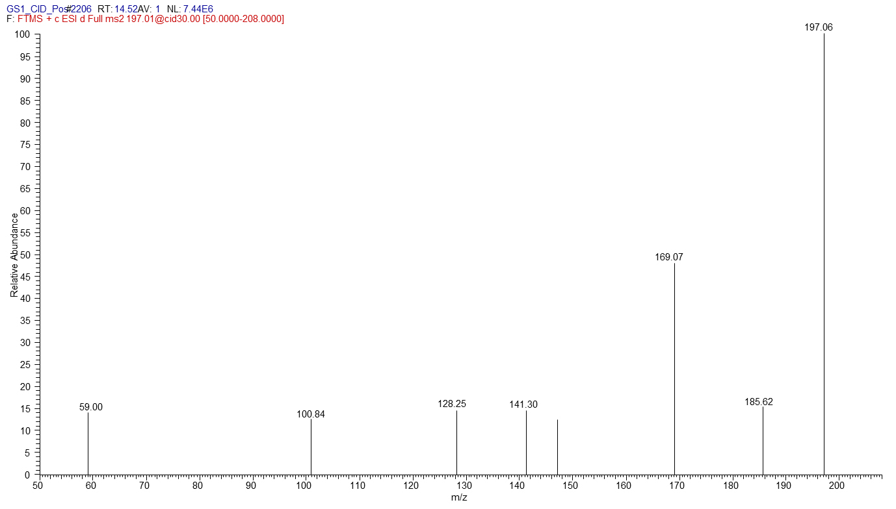
Figure S7. MS/MS spectrum of 2-hydroxyphenazine (2-OH-Phz), m/z [M + H]⁺ 197

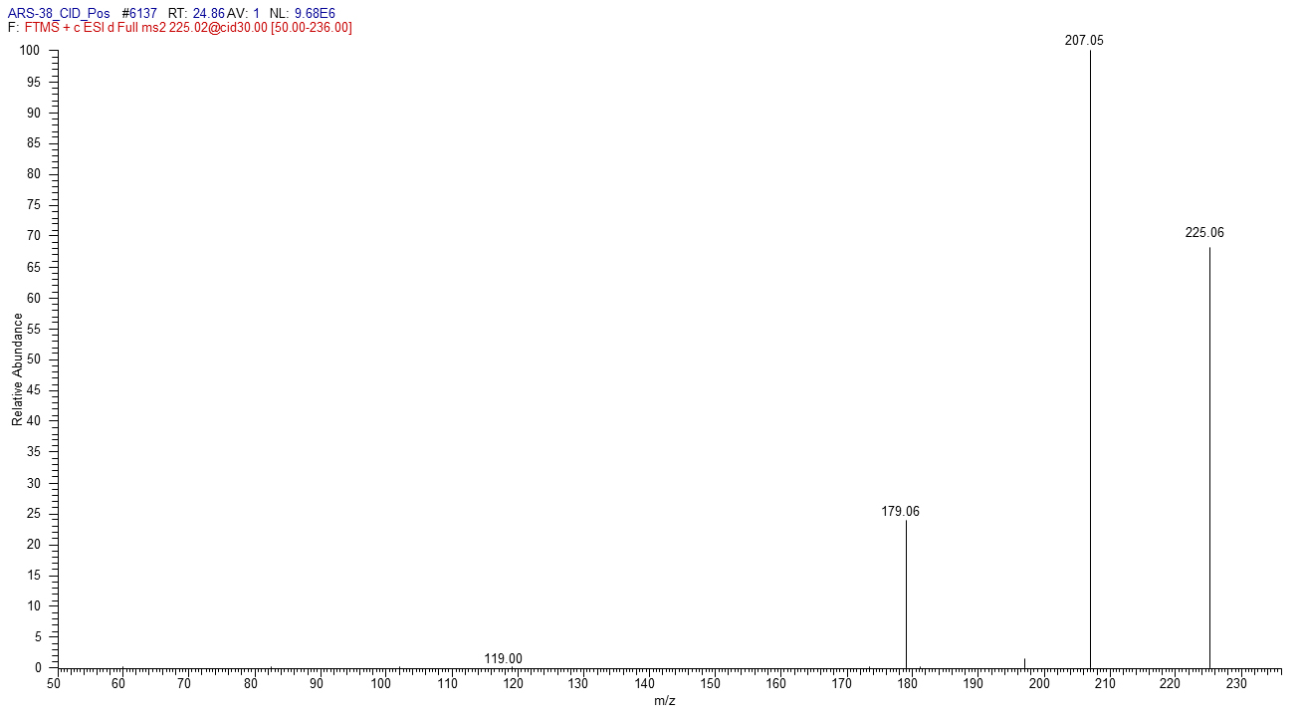
Figure S8. M/MS spectrum of phenazine-1-carboxylic acid (PCA), m/z [M + H]⁺ 225

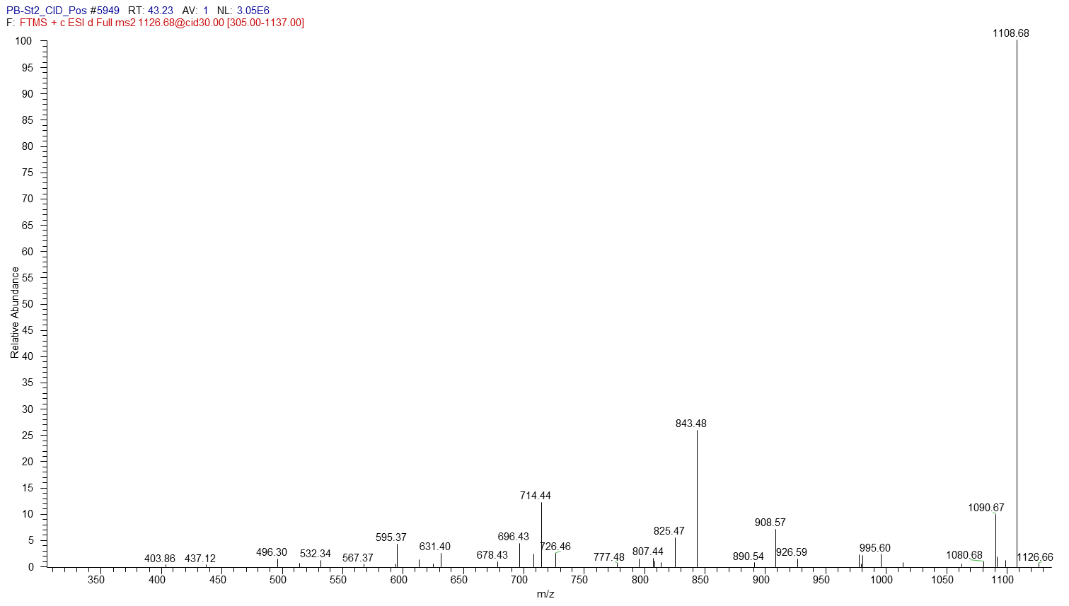
Figure S9. M/MS spectrum of White line inducing principle (WLIP), m/z [M + H]⁺ 1126

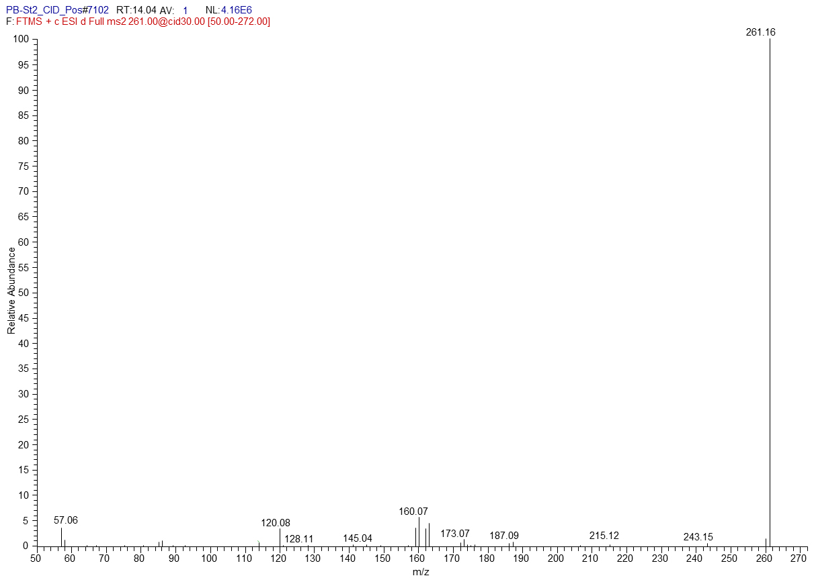
Figure S10. M/MS spectrum of Lahorenoic acid A, m/z [M + H]⁺ 261

